

EXPERIMENT REPORT

|  |  |
| --- | --- |
| **Experiment Name** | Nonlinear Operational Amplifier Applications |
| **Assistant Name** | Mehmet Nuri Akıncı |
| **Student**  **(Name / Number / Department)** | Alihan Polat / 040110207  /Electronics and Communication Engineering |
| **Group Number and Experiment Date** | D14-10.10.2014 |

|  |  |  |
| --- | --- | --- |
| **Report Grade** | **Delivery Date** | **Acception Date** |
|  | 17.10.2014 |  |

**EXPERIMENT 5**

**Nonlinear Operational Amplifier Applications**

**Purpose of the experiment**

The primary objectives of this experiment is to investigate some nonlinear applications of operational amplifiers such as voltage comparator, Schmitt trigger and rectifier circuits.

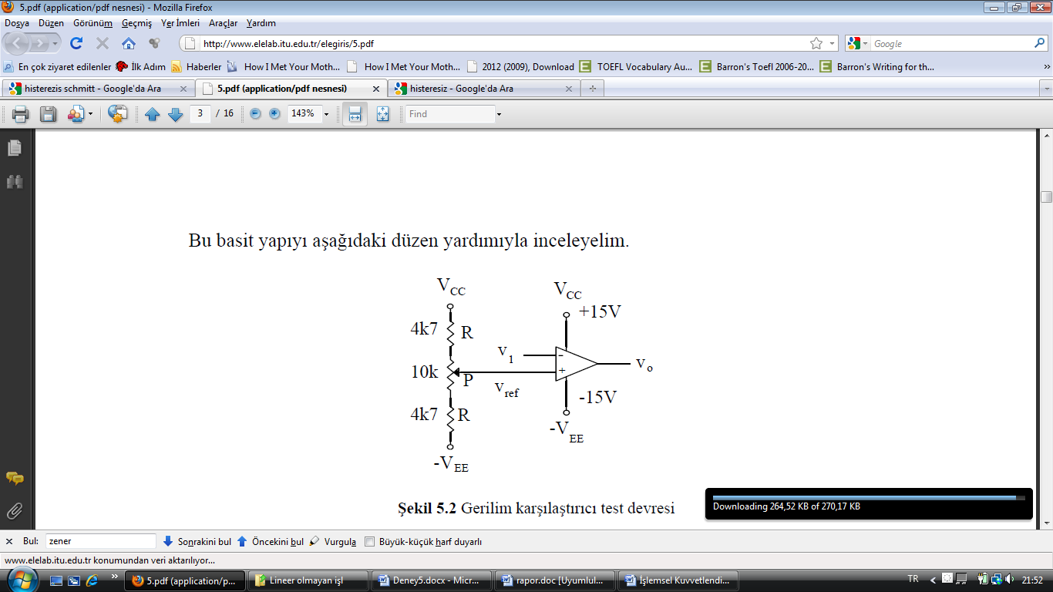**Experiment 1:**

We constructed the voltage comparator circuit shown in Figure-1. 100 Hz and 10 V peak-to-peak triangle wave signal is applied a at the V1 input. We set the VREF to 0V. And we sketched the V1 and Vo  graph to protocol paper.

Figure 1

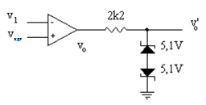**Experiment 2:**

We constructed the voltage-limited comparator circuit shown in Figure-2. 100 Hz and 10 V peak-to-peak triangle wave signal is applied a at the V1 input. We set the VREF to 0V. And we sketched the V1 , Vo and Vo’ graph to protocol paper.

Figure 2

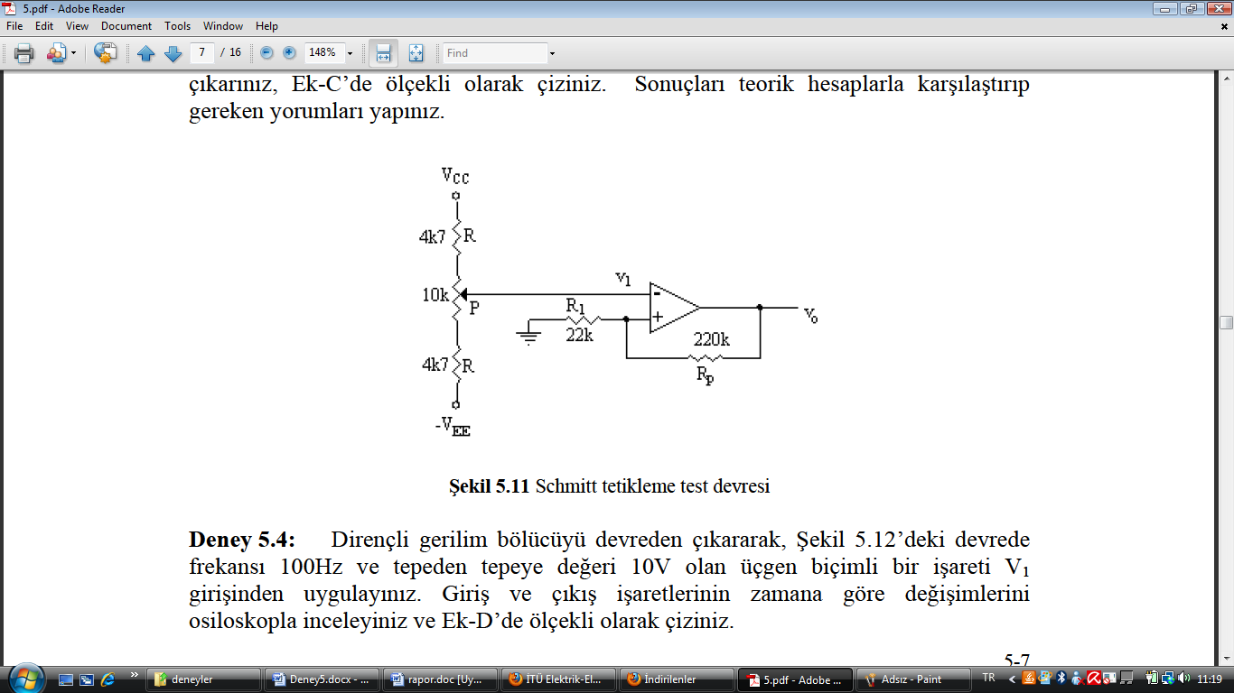**Experiment 3:**

We constructed the Schmitt trigger circuit shown in Figure-3. Then we changed the input V1 voltage by potentiometer. We measured when Vo goes to high and goes back to low. And sketched V1 and Vo characteristics.(Hysteresis behavior)

Theoretical Calculations

When Vo = +15V

Figure 3

Vp = (22k/242k)x(15V) = 1.364 => V11 = 1.364V

When Vo = -15V

Vp = (22k/242k)x(-15V) = -1.364 => V12 = -1.364

Measured V11 and V12 Values

V11 = 1.5V and V12 = -1V

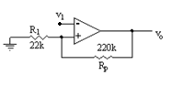**Experiment 4:**

The circuit that constructed previous experiment is used in this experiment too. We applied at V1 input100 Hz and 10 V peak-to-peak triangle wave signal. And sketched the V1 and Vo waveforms to protocol paper.

**Experiment 5:**

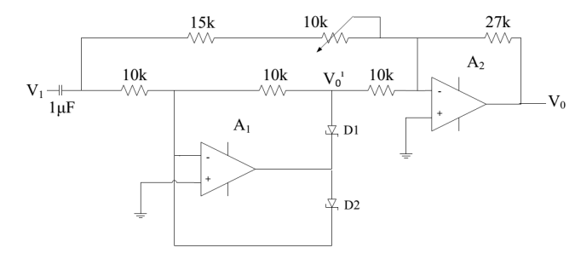We constructed the full-wave rectifier circuit shown in Figure 5. 1kHz and 10 V peak-to-peak sinusoidal signal at the V1 input and provided a full-wave rectifier operation for the circuit by trimming the potentiometer. And we sketched the V1 , Vo and Vo’ graph to protocol paper. It is seen that Vo’ is half wave rectified and Vo is full wave rectified.